**Methods**

**Sample and Data**

**Measures**

***Cross-Cutting Exposure***

***Engagement***

***Outcomes***

***Controls***

The study includes demographic controls, including *age*, *gender* (1 = female), *race* (1 = person of color), *education* (1 = No high school diploma, 7 = post-graduate degree), and *income* (1 = < $15,000 per year, 8 = > $150,000 per year). Additionally, the study controls for *Facebook use frequency* (1 = Less than 30 minutes per day, 6 = More than 3 hours per day), *network size* (1 = Less than 50, 6 = More than 2,000), and *network diversity* (previously validated index of 22 binary items asking whether respondents know people who work in various occupations). See Table 1 for descriptive statistics.

**Plan of Analysis**

**Results**

First, we assessed the extent of cross-cutting exposure in reported news use with descriptive statistics, *t*-tests, and χ2-tests. The mean of the general cross-cutting exposure variable is *M* = -0.18 (*SD* = 1.18), and the mean of the name generator variable is *M* = -0.41 (*SD* = 1.44). Zero is the midpoint on the scales for both measures, and the negative means indicate that people report more like-minded exposure than cross-cutting exposure (see Figure 1). One-sample *t*-tests confirm that these means are significantly below the scale midpoints. For the general measure, the test statistic is *t* (403) = -3.00 (*p* < .01); for the name generator measure, it is *t* (1113) = -9.47 (*p* < .001). These differences amount to approximately 4% and 8% of the respective scales. For the name generator measure, it is also worth looking at how many names respondents reported were like-minded versus cross-cutting (see Figure 2). Respondents named 1.99 times more like-minded posters (634, in total, or 57%) than cross-cutting posters (319, in total, or 29%), and this difference is statistically significant with a test statistic of χ2 (1) = 72.51 (*p* < .001). The remaining names were reported as neutral (161, or 14%).

Second, we tested the relationship between cross-cutting exposure and the outcome variables (see Table 2). The coefficients for the general outcomes are relatively small, but two out of three are statistically significant. All coefficients are negative, indicating that the outcomes are more likely to be related to like-minded exposure rather than cross-cutting exposure (see Figure 3). For social connectedness, the effect is β = -0.05 (*SE =* 0.02, *p* < .05). For community belongingness, it is β = -0.06 (*SE =* 0.03, *n.s.*). Finally, for social trust, it is β = -0.08 (*SE =* 0.02, *p* < .001). Larger negative effects are observed for the name generator outcomes, with the largest being for perceived similarity, which has an effect of β = -0.43 (*SE =* 0.02, *p* < .001), followed by closeness, with an effect of β = -0.48 (*SE* = 0.04, *p* < .001). The effect for liking is the smallest of the three, with a coefficient of β = -0.27 (*SE =* 0.02, *p* < .001). These results support the idea that exposure to cross-cutting news on Facebook is negatively related to a variety of interpersonal outcomes relevant for the formation and maintenance of community.

Third, we evaluated the strength of the relationship between cross-cutting exposure and news engagement. The two general variables have a weak negative correlation (*r* = -.16, *p* < .001), while the relationship between the two name generator variables is stronger (*r* = -.53, *p* < .001). These results suggest that people tend to engage more with like-minded content than they do with cross-cutting content. To confirm this finding, we performed an ANOVA with the name generator measures, treating the engagement variable as the outcome and the count measure of cross-cutting exposure as a categorical factor (see Figure 4). Results show a significant difference between the like-minded names and the neutral and cross-cutting names. The omnibus test is statistically significant with *F* (2, 1111) = 206.70, *p* < .001. Meanwhile, Tukey HSD pairwise comparisons show that the mean engagement in the like-minded category (*M*  = 2.27) is significantly higher (*p* < .001) than the means in the neutral (*M* = 1.64) and cross-cutting (*M* = 1.63) categories, which are not significantly different from one another. In all, these results confirm that people report higher levels of engagement with like-minded news posters.

Finally, we tested whether news engagement moderates the above relationships. Only two of the six interactions we tested were statistically significant. For social trust, the interaction coefficient is β = 0.07 (*SE =* 0.03, *p* < .05); for perceived similarity, it is β = 0.09 (*SE =* 0.04, *p* < .01). Both of these are positive, indicating that the negative effect of cross-cutting exposure is weakest at the highest levels of engagement (see Figures 5 and 6). In all, these results suggest that engagement may counteract the negative effects of cross-cutting exposure.

|  |  |  |  |  |  |
| --- | --- | --- | --- | --- | --- |
| Table 1  *Descriptive Statistics* |  |  |  |  |  |
| Variable | No. of Items | Scale | Cronbach’s Alpha | *M* (%) | *SD* |
| Cross-Cutting Exposure (wide) | 2 | -4-4 | NA (index) | -0.18 | 1.18 |
| Cross-Cutting Exposure (long) | 3 (1 per name) | -2-2 | .75 | -0.41 | 1.44 |
| Engagement (wide) | 4 | 1-5 | .91 | 3.05 | 1.16 |
| Engagement (long) | 21 (7 per name) | 1-3 | .96 | 2.00 | 0.60 |
| Social Connectedness | 20 | 1-5 | .74 | 3.29 | 0.53 |
| Community Belongingness | 6 | 1-5 | .90 | 3.32 | 1.03 |
| Social Trust | 3 | 1-5 and 1-7 (standardized) | .85 | 0.01 | 0.91 |
| Perceived Similarity | 3 (1 per name) | 1-5 | .80 | 3.46 | 1.27 |
| Liking | 3 (1 per name) | 1-5 | .74 | 4.19 | 0.97 |
| Closeness | 3 (1 per name) | 1-7 | .79 | 3.81 | 2.10 |
| Network Diversity | 22 | 0-1 | NA (index) | 9.55 | 6.09 |
| Network Size | 1 | 1-7 | NA | 3.91 | 1.41 |
| Facebook Use Frequency | 1 | 1-6 | NA | 3.39 | 1.65 |
| Income | 1 | 1-8 | NA | 4.43 | 2.28 |
| Education | 1 | 1-7 | NA | 4.54 | 1.86 |
| Race | 1 | 0-1 | NA | (44.8) | NA |
| Gender | 1 | 0-1 | NA | (50.3) | NA |
| Age | 1 | 18-87 | NA | 44.28 | 16.03 |

|  |  |  |  |  |  |  |
| --- | --- | --- | --- | --- | --- | --- |
| Table 2  *Regression Results* | | | | | | |
|  | Social Connectedness | Community Belongingness | Social Trust | Perceived Similarity | Liking | Closeness |
| Variable | β (*SE*) | β (*SE*) | β (*SE*) | β (*SE*) | β (*SE*) | β (*SE*) |
| Intercept | 2.76 (0.15)*** | 2.34 (0.26)*** | -0.11 (0.24) | 2.78 (0.25)*** | 3.15 (0.20)*** | 2.36 (0.50)*** |
| Age | -0.00 (0.00) | -0.00 (0.00) | -0.01 (0.00)* | 0.00 (0.00) | 0.01 (0.00)*** | 0.00 (0.01) |
| Gender (1 = Female) | 0.03 (0.06) | -0.37 (0.10)*** | -0.47 (0.09)*** | -0.15 (0.09) | -0.00 (0.08) | 0.13 (0.19) |
| Race (1 = Person of Color) | -0.06 (0.05) | -0.05 (0.09) | -0.19 (0.08)* | 0.00 (0.09) | 0.15 (0.07)* | 0.08 (0.18) |
| Education | 0.02 (0.02) | 0.08 (0.03)* | 0.07 (0.03)** | 0.01 (0.03) | 0.00 (0.02) | -0.02 (0.06) |
| Income | -0.00 (0.010 | 0.09 (0.02)*** | 0.03 (0.02) | 0.04 (0.02) | 0.02 (0.02) | 0.13 (0.05)** |
| Facebook Use Frequency | 0.07 (0.02)*** | 0.10 (0.03)*** | 0.05 (0.03) | 0.01 (0.03) | -0.00 (0.00) | 0.04 (0.06) |
| Network Size | 0.06 (0.02)** | 0.00 (0.04) | -0.02 (0.03) | 0.06 (0.04) | 0.01 (0.03) | 0.04 (0.07) |
| Network Diversity | -0.00 (0.00) | 0.03 (0.01)*** | 0.02 (0.01)* | 0.01 (0.01) | 0.01 (0.01) | 0.02 (0.02) |
| **Cross-Cutting Exposure** | **-0.05 (0.02)\*** | **-0.06 (0.03)** | **-0.08 (0.03)\*** | **-0.43 (0.02)\*\*\*** | **-0.27 (0.02)\*\*\*** | **-0.48 (0.04)\*\*\*** |
| SD Intercept |  |  |  | 0.68 | 0.53 | 1.45 |
| SD Residual |  |  |  | 0.78 | 0.67 | 1.35 |
| *R*2 | 0.14 | 0.32 | 0.25 |  |  |  |
| *LL* |  |  |  | -1558.68 | -1364.29 | -2214.82 |
| *N* | 404 | 404 | 404 | 1114 | 1114 | 1114 |
| *Note:* Cell entries are estimates from ordinary least squares (OLS) regression models (Columns 2-4) and multilevel models (Columns 5-7).  \**p* < .05, \*\**p* < .01, \*\*\**p* < .001. | | | | | | |

Figure 1

*Sample Distributions of Cross-Cutting Exposure Measures*

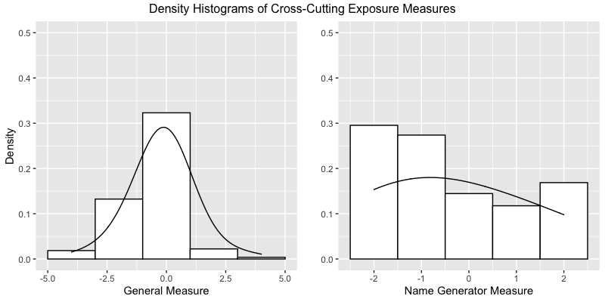

Figure 2

*Bar Plot of Counts for Cross-Cutting (CCE), Neutral (NEU), and Like-Minded (LME) Names in the Name Generator Portion of the Survey*

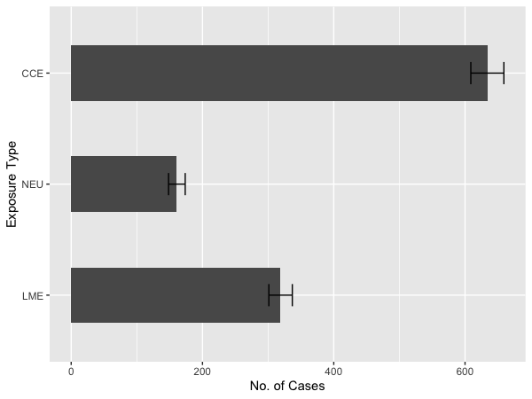

Figure 3

*Effect Estimates from Regression Models*

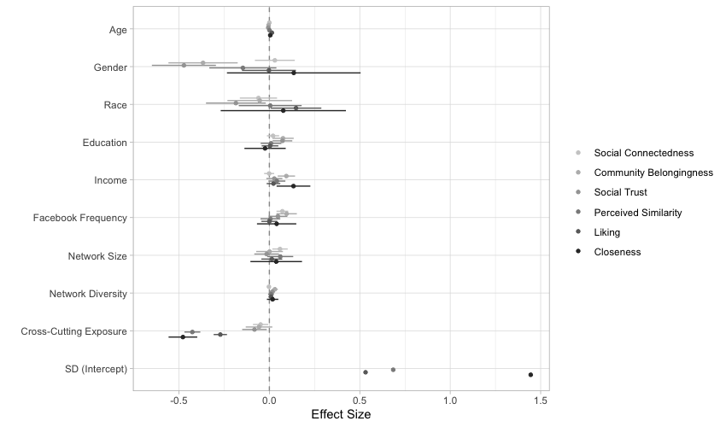

Figure 4

*Box Plot of Engagement by Exposure Type (CCE: Cross-Cutting Exposure; NEU: Neutral; LME: Like-Minded Exposure)*

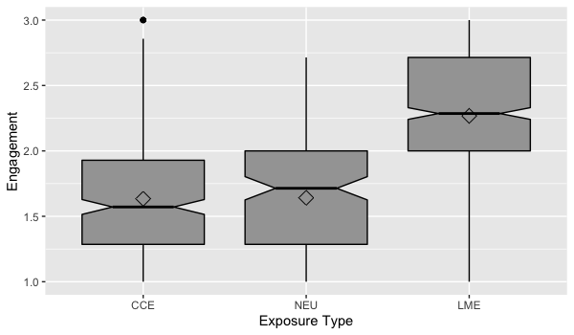

Figure 5

*Relationship between Cross-Cutting Exposure and Social Trust at Low, Medium, and High Levels of News Engagement*

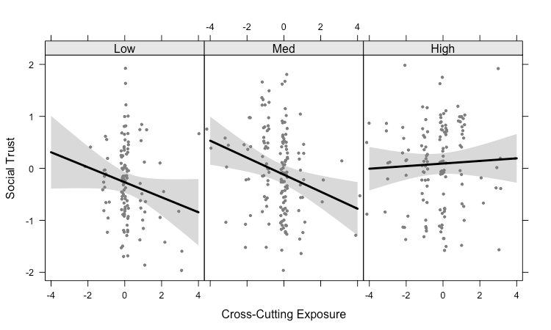

Figure 6

s

*Conditional Relationship between Cross-Cutting Exposure and Perceived Similarity at Low, Medium, and High Levels of News Engagement*

